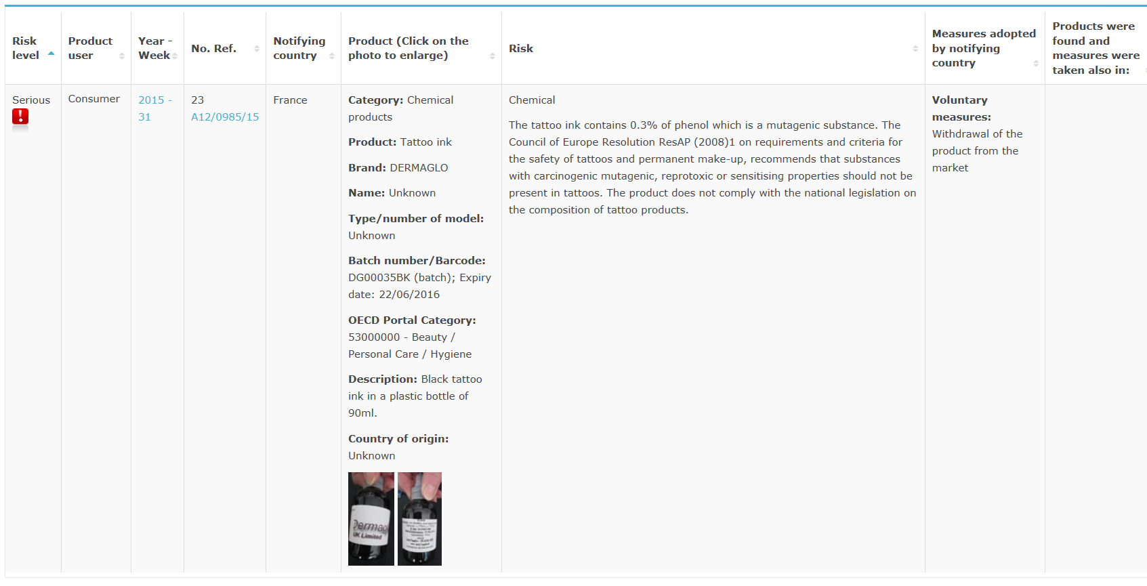

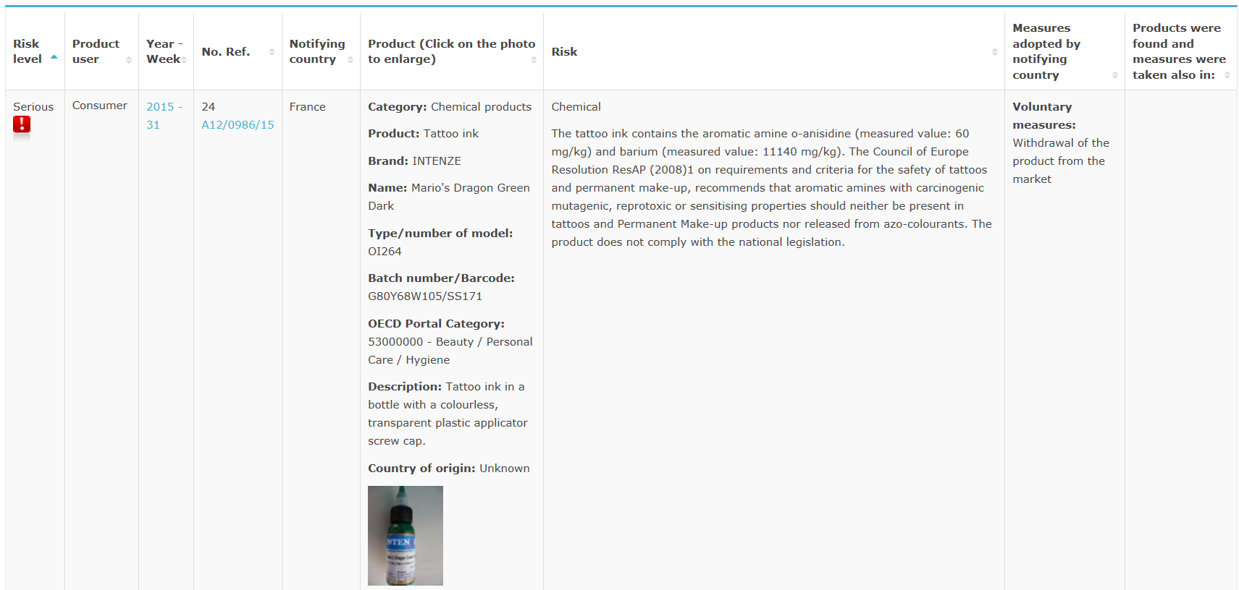

<http://ec.europa.eu/consumers/safety/rapex/alerts/main/index.cfm?event=main.search>